Real Estate Price Prediction and Analysis

Motivation and Objective
The real estate industry has always been a popular avenue for financial transactions, and accurately estimating the market value of a property is crucial for both buyers and sellers. Buyers want to avoid overpaying, while sellers want to avoid selling for less than the property is worth due to an inaccurate estimate.
Machine learning algorithms have shown promise in predicting prices and forecasting business trends, but choosing the right model for a particular situation can be challenging. This paper aims to demonstrate the most effective machine learning algorithms for predicting real estate prices through experiments, analyses, and comparisons of various models.
Related Work and Originality
The process began with collecting and pre-processing data, followed by cleaning the data and splitting it into train and test sets. Model training and comparisons were then conducted. However, after reviewing related works, the authors identified areas for improvement. Some states in their dataset had insufficient data, so the authors decided to exclude them and only train the models with the remaining data. Additionally, the authors utilized more cross-validation to reduce bias and enhance the model's performance further.
Design Architecture
The data used in this study was obtained from www.realtor.com, a real estate listing website owned by Move, Inc., a subsidiary of News Corp, located in Santa Clara, California. As of 2021, the website is the second most popular real estate listing site in the United States, with over 100 million monthly active users. The paper consists of several parts. Firstly, the raw data from www.realtor.com was processed to eliminate duplicates and invalid items. The data was then modeled and divided into a training set and test set. Next, various machine learning models, such as linear regression, polynomial regression, decision tree regressor, random forest, and xgboost, were trained and optimized by adjusting their parameters. Finally, the authors presented an overview of the system.
Detailed Algorithm or Functions
1. Data Cleaning
The original csv file contains 900k+ data records broken by State and zip code. The dataset has 12 columns, which are status, price, bed, bath, acre lot, full address, street, city, state, zip code, house size, and sold date. First they dropped duplicated data. Secondly, dropped some columns that will not be used as features in model training such as status, acre lot, full address, street, and sold date. For the columns left, they checked and dropped any rows that include missing value in it. Thirdly, authors removed outliers for price, bed, bath, and house size that were 3 standard deviations above the mean.
2. Linear Regression
The reason for choosing the linear regression model was very simple and natural. Generally speaking, the more rooms a house contains and the larger the area, the higher the price of the house will be. The linear model is the simplest and most direct model to express this logic. However, in the actual problem, the prediction of house prices was obviously not such a simple linear logic, so they also used Elastic Net, Lasso and Ridge regression.
3. Polynomial Regression
Also authors considered more complex linear relationships, polynomial regression. But generally, polynomial regression would have complex multicollinearity problems, so they decided to use Polynomial Features first to transform dataset to contain multicollinearity features, and also consider how to solve multicollinearity problems in experiments.
4. Decision Tree Regressor
Decision tree is a model for decision making based on tree structure. Common decision tree nodes are divided into the following three types: ID3 decision tree, C4.5 decision tree, and CART decision tree. (ID3 classifies based on information entropy and information gain; C4.5 classifies based on information gain rate; CART performs regression analysis based on Gini coefficient) The algorithm used in Sklearn is CART decision tree, and CART regression algorithm uses the criterion of minimizing mean square error to select features and generate a binary tree.
5. Random Forest Regressor
Random Forest is a popular supervised machine learning algorithm that consists of multiple decision trees. In a random forest, a set of decision trees are trained on a random subset of the data. Each tree makes a prediction, and the final prediction is made by combining the predictions of all the decision trees. The idea behind this approach is that by training multiple decision trees on different subsets of the data, the random forest can reduce the overfitting that can occur when training a single decision tree on the entire dataset.
6. XGBoost Regressor
XGBoost is a large-scale parallel boosting tree tool. To put it simply, start with the XGBoost objective function, generate a tree, and then continue to generate a decision tree above this decision tree. With the increase of the number of layers, its accuracy will gradually increase.
Coding
1. Linear Regression
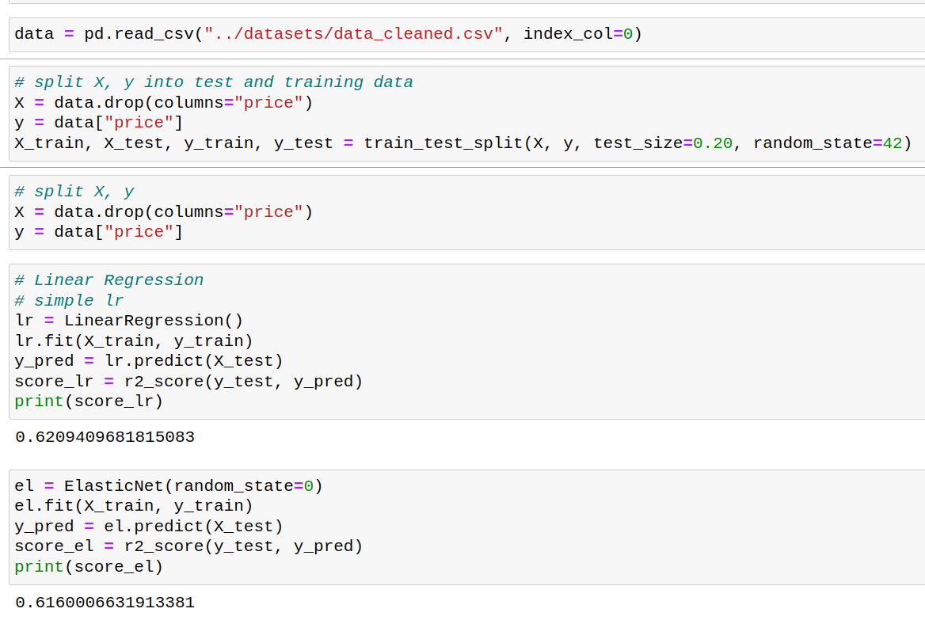
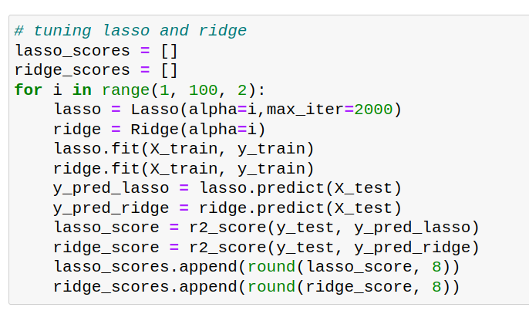
2. Polynomial Regression
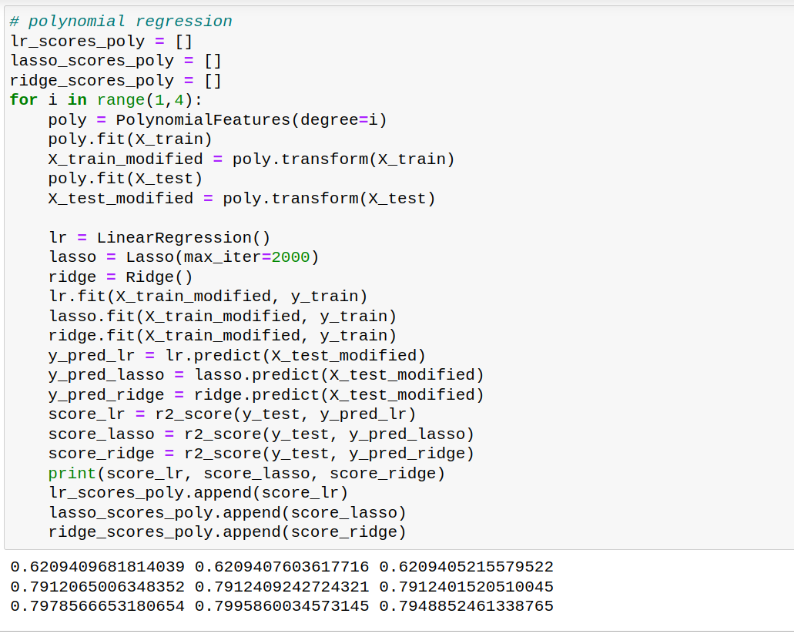
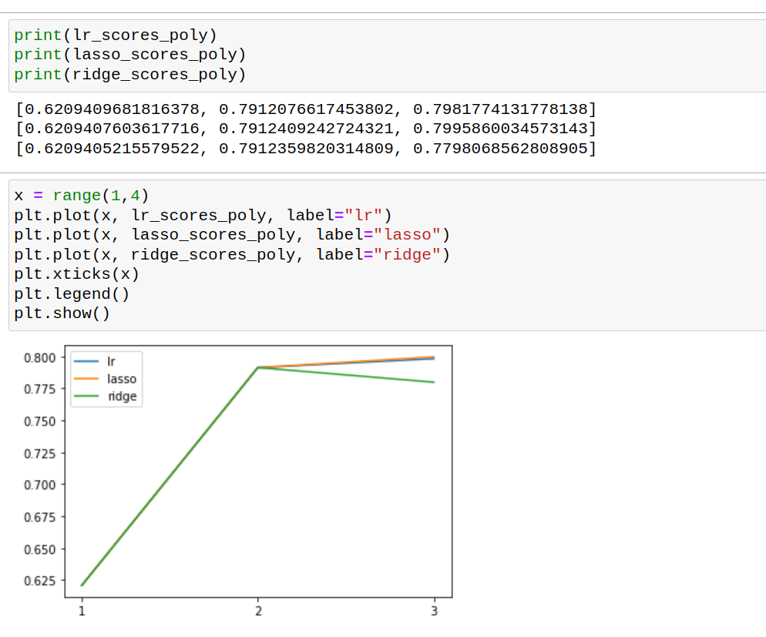
3. Decision Tree Regressor
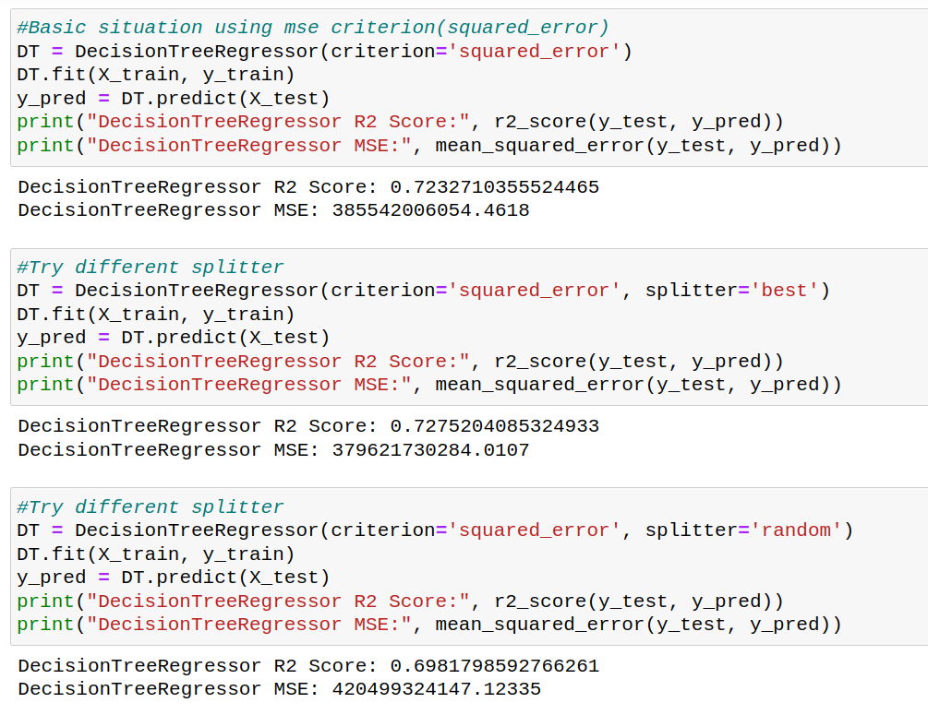
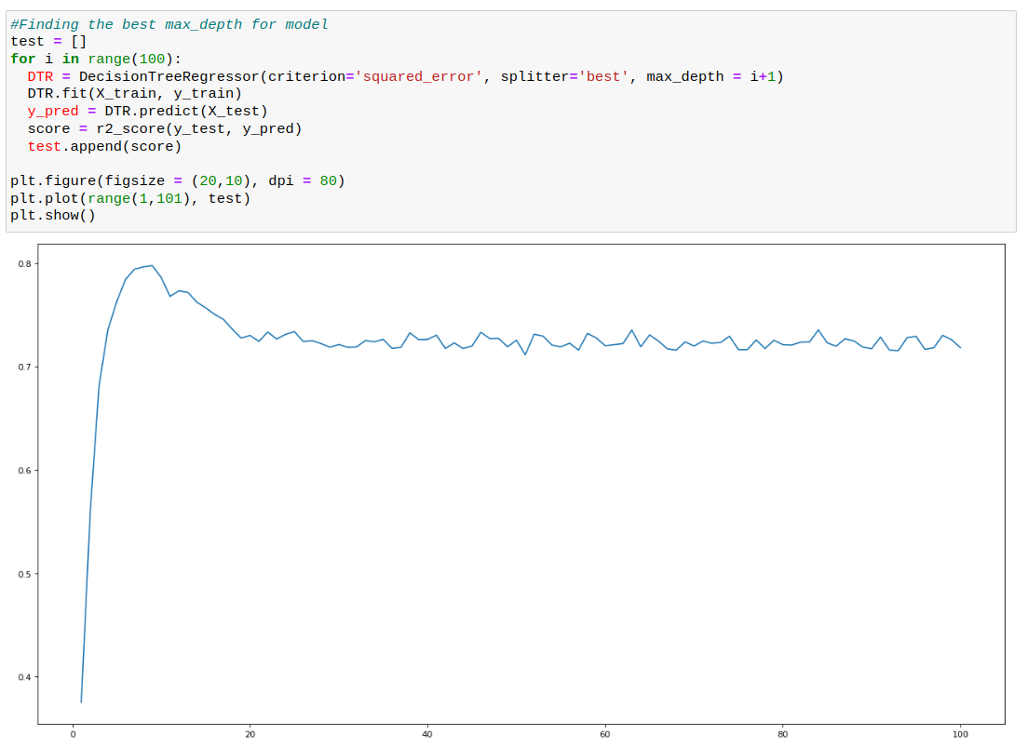
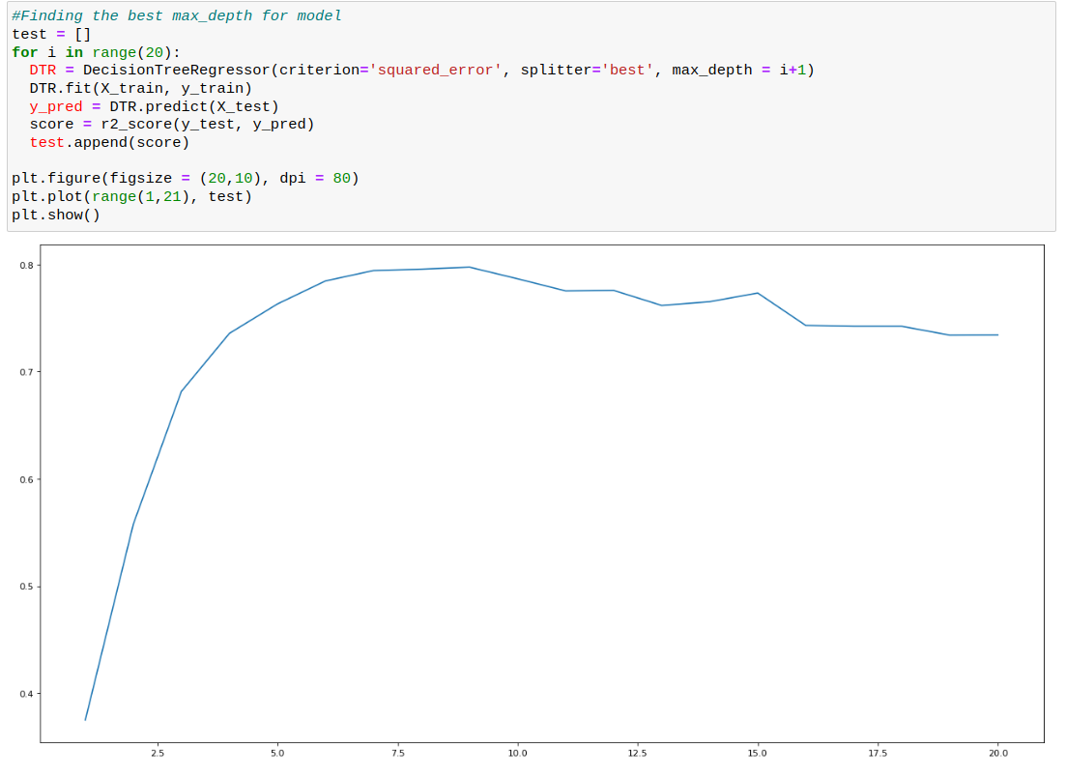
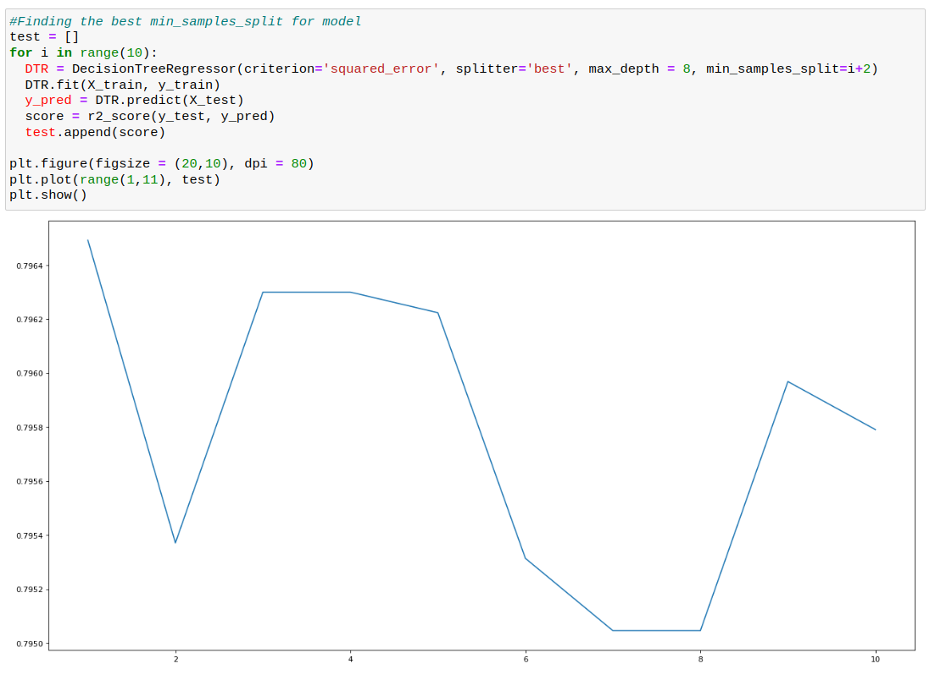
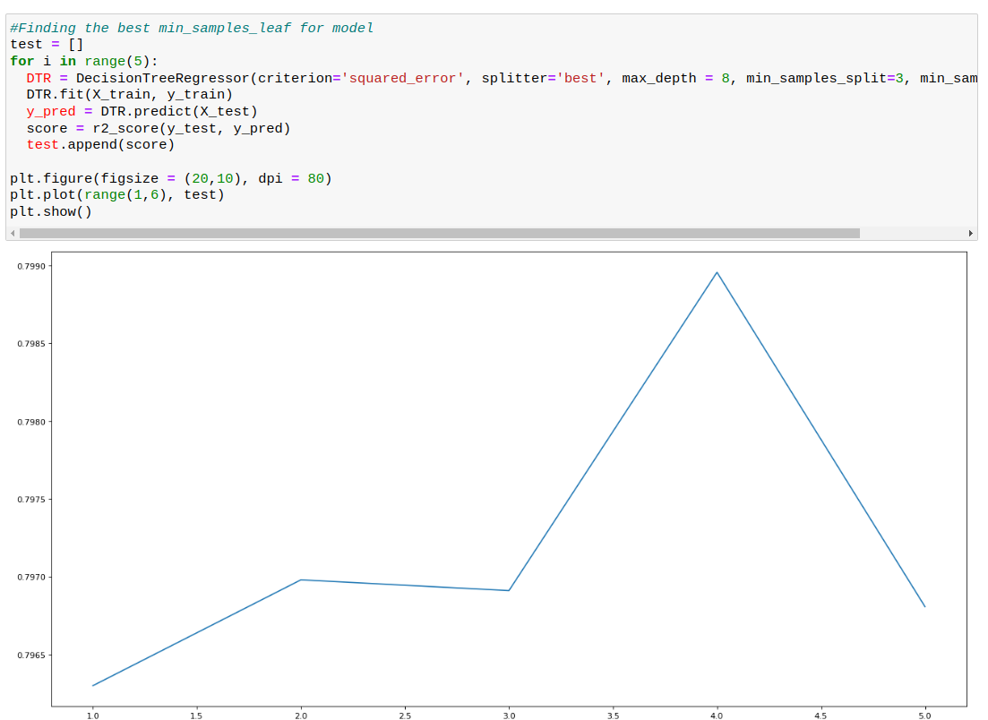
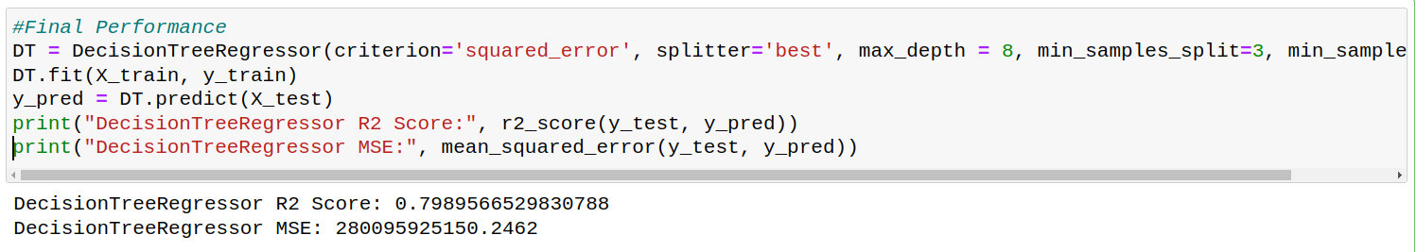
4. Random Forest Regressor
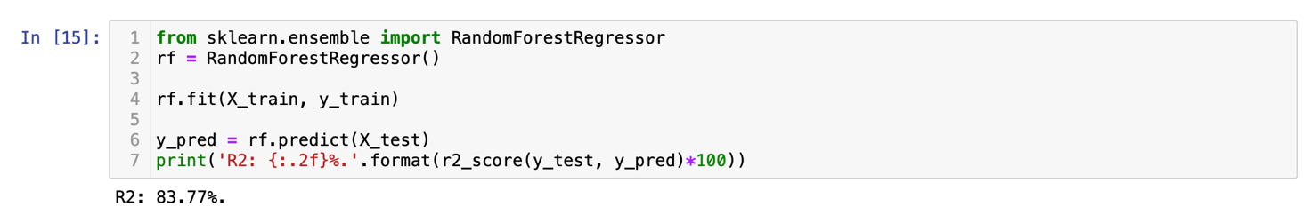

5. XGBoost Regressor
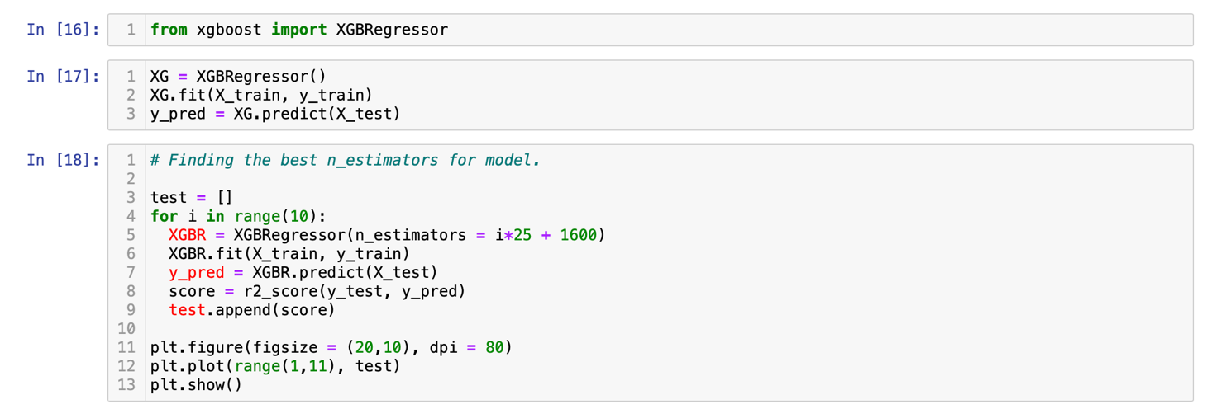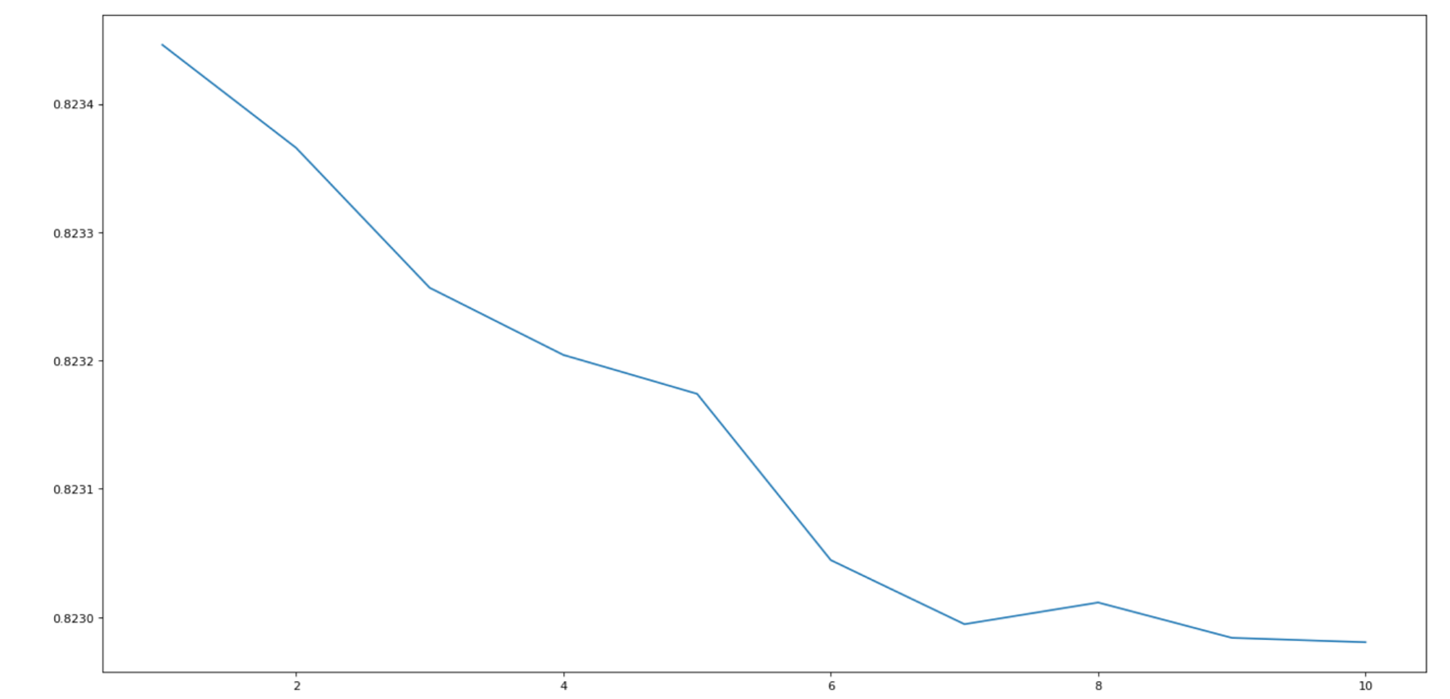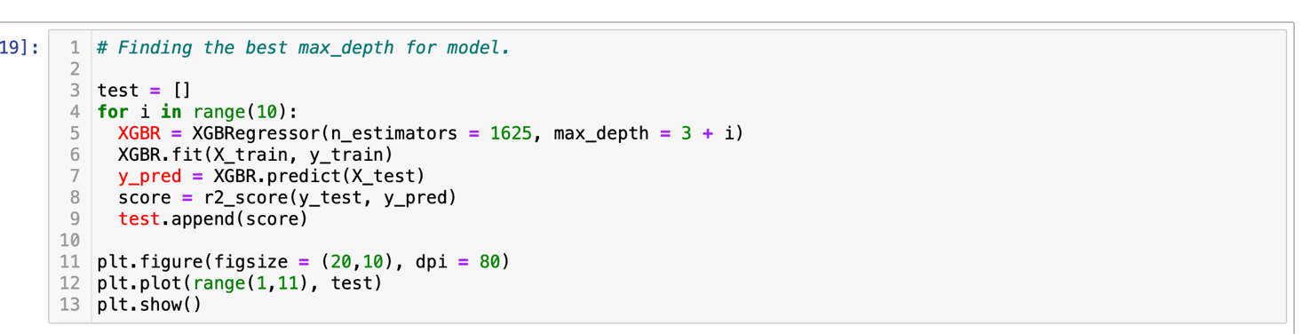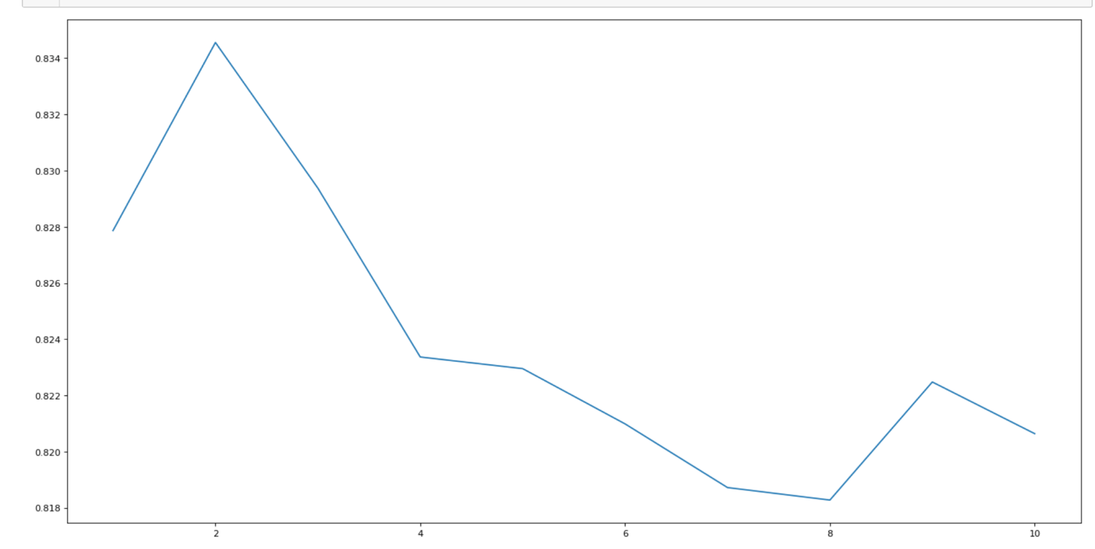
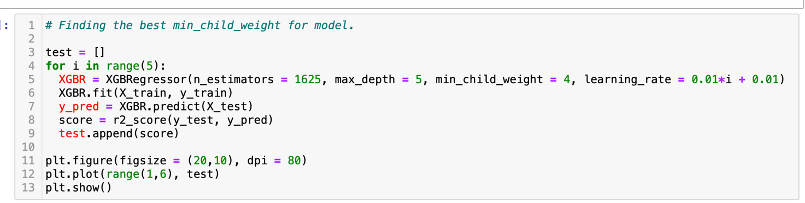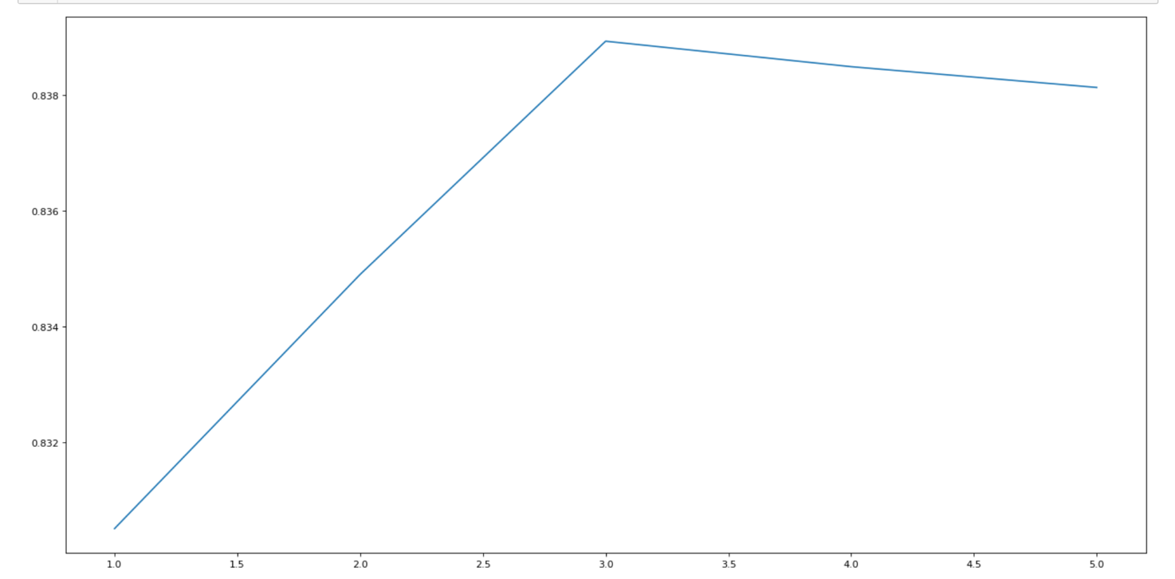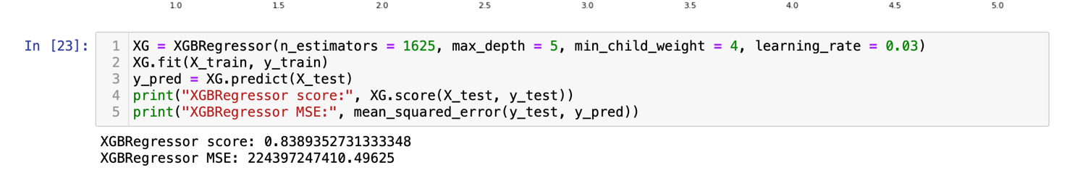

Results and Performance Evaluation
1. Linear Regression
First of all, they fit the simple Linear Regression model with cleaned data and used R2 score as metric. The score was 0.6208776, which is not good. Then they trained other linear regression models, which were Elastic Net , Lasso and Ridge Regression, and turned hyperparameters on them. By giving different values of alpha, the R2 score stayed stably around 0.6208, which is similar to simple linear regression. This drew them to the idea that Linear Models was not good enough for this dataset.
2. Polynomial Regression
Since Scikit-Learn does not provide a polynomial regression directly, they simulated the polynomial regression by transforming the data set into a new dataset with polynomial features using ’PolynomialFeatures’, and then applied Linear Regression, Lasso, and Ridge on the data set. The highest R2 score for LR was 0.79652. The highest R2 score for Lasso was 0.80021. The highest R2 score for Ridge was 0.79116.
3. Decision Tree Regressor
Directly applied decision tree regressor algorithm in sklearn library has a R2 score of about 0.7107. And, after a few training it appears the combination of squared error criterion and best splitter works better on dataset. The first focus should be on tuning the max depth of the model, which refers to the max possible depth of layers of the decision tree. And they reach a score of about 0.7818 here. The minimum samples split can also influence the performance. Then it lands at about 0.7973 here. Finally authors reached a R2 performance score of almost 0.8 with max depth of 8, min samples split of 3 and min samples leaf of 4. The R2 score increases about 12%, and the MSE decreases over 30%.

4. Random Forest Regressor
Hyperparameter tuning is necessary to achieve optimal performance in training random forests, and the authors use randomized search and 3-fold cross-validation to achieve this. They select six hyperparameters with 20 candidates each, resulting in 60 model fits, and achieve a highest R2 score of 83.77%. The best hyperparameters include n_estimators=500, max_features=sqrt, max_depth=100, min_samples_split=2, min_samples_leaf=2, and bootstrap=True. The encoded zipcode is found to be the most important feature in the best random forest model, likely due to the variance in price across different states and cities. However, the use of target encoding may have leaked information about the target variable.

5. XGBoost Regressor
The default XGBoost regressor algorithm has an R2 score of about 0.8146 and similar mean squared error to the tuned Decision Tree Regressor. The authors tuned the maximum number of iterations and settled on a range of 1600-1800 with a step of 25, and chose a learning rate of 0.05. They experimented with gamma but found it did not have a significant impact on the results. The final selected hyperparameters for XGBoost were n_estimators = 1700, max_depth = 7, min_child_weight = 3, gamma = 0.1, and learning_rate = 0.05, resulting in an R2 score of about 0.8389, which outperformed the best score of the Random Forest model. So, finally, the score is 0.8389352.

Conclusion
The authors developed a model that can help homebuyers purchase properties at fair market prices and provide accurate pricing forecasts for real estate companies.
This user-friendly system utilizes data to predict prices for various homes with different features, and after conducting experiments, the XGBoost algorithm was found to be the most effective. However, during the development of the system demo, the Random Forest algorithm was found to perform better than XGBoost for data from New York and New Jersey only, likely due to the dataset's limited coverage of all states, resulting in lower model accuracy. To improve the system's performance, the authors suggest collecting more comprehensive or even real-time datasets and adding more features to make the model more robust, including the transaction date as a crucial factor as prices fluctuate over time.
Reference
[1] Smith Dabreo, Shaleel Rodrigues, Valiant Rodrigues, and Parshvi Shah. Real estate price prediction. International Journal of Engineering Research and Technology (IJERT), 10(4), 2021. 1
[2] Sayar Kumar Dey and Siddhaling Urolagin. Real estate price prediction using data mining techniques. In 2021 IEEE 4th International Conference on Computing, Power and Communication Technologies (GUCON), pages 1–4, 2021. 1
[3] Meghana Tribhuwan and Snehal Godse. Valuation of house prices using predictive machine learning techniques. SSRN, 2022. 1

Roles of Members
Alibaev Elnur - Motivation and Objective, Related Work and Originality, Detailed Algorithm or Functions (Linear Regression, Polynomial Regression, Decision Tree Regressor), Coding (Linear Regression, Polynomial Regression, Decision Tree Regressor), Results and Performance Evaluation (Linear Regression, Polynomial Regression, Decision Tree Regressor)
Kozhakhmet Nagashybaiuly – Design Architecture, Detailed Algorithm or Functions (Random Forest Regressor, XGBoost Regressor), Coding (Random Forest Regressor, XGBoost Regressor), Results and Performance Evaluation (Random Forest Regressor, XGBoost Regressor), Conclusion, Reference

Github - https://github.com/ElnurAlibaev/MLProject/tree/main

